`

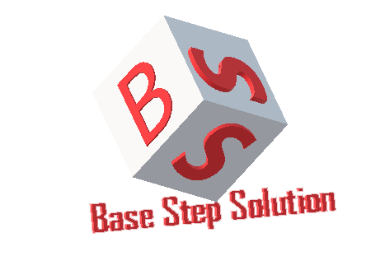

Software Architect Process Architectural Process

Van Lang Admissions

# Revision Table

|  |  |  |  |
| --- | --- | --- | --- |
| **Author** | **Date** | **Reason for changes** | **Version** |
| Tai Nguyen | 2/11/2016 | Architectural Process | 1.0 |
| Hien Nguyen | 27/11/2016 | Edit process, activities, roles and add tool and method | 1.1 |
| Khoi Nguyen | 24/5/2016 | Fix template | 2.0 |

Table of Contents

Revision Table 1

1. INTRODUCTION 3

1.1. Purpose 3

1.2. Audience 3

2. Process 4

2.1. Process flow 4

2.2. Activities 4

2.3. Roles and Responsibility 5

3. TOOLS AND METHODS 5

# INTRODUCTION

## Purpose

Overview about architect of Project, help team understand about architect of Project and make a clear architect from all views.

## Audience

The intended audience of the AR Plan is

|  |  |
| --- | --- |
| **Intended Audience** | **Description** |
| All members | All member have a meeting and discuss about process |
| The mentor | People give an advice and support group during Architect process. |

# Process

## Process flow



## Activities

|  |  |  |  |
| --- | --- | --- | --- |
| **Stage** | **Description** | **Activities** | **General output** |
| 1 | **Create Architecture:** | 1. All members base on System context, create dynamic views, static views, and physical views by patterns.  2. All members decompose all views into a lower level views. Until all views are clear. | Architecture Views |
| 2 | **Architecture Review:** | 1. All members analyze all views and define risks and tradeoffs if apply those patterns. | Risks and tradeoffs list |
| 3 | **Production Go/No-Go:** | All members discuss and architect leader give a decision:  1.If we know all risks and tradeoffs, we move to Go and done this phrase.  2. Else we move to Not Go and come to next step. |  |
| 4 | **Plan Experiments** | 1. Architect leader will plan to experiment risks and tradeoffs list. | Experiment research plans |
| 5 | **Execute Experiment** | 1. All members execute plan and give a report result.  2. Base on report, we will refine architectural. | Experiment results |

## Roles and Responsibility

|  |  |  |
| --- | --- | --- |
| **No** | **Role** | **Responsibility** |
| 1 | Project Manager | Is responsible for coordinating the overall system design and development effort. They also solve problem between stakeholder. |
| 2 | Architect Leader | Is responsible for giving decision go or not go and planning to experiment risks and tradeoffs |
| 3 | All members | Is responsible for creating architect views, analyze views and executing plan. |

1. TOOLS AND METHODS

|  |  |  |
| --- | --- | --- |
| **No** | **Tools and methods** | **Description** |
| 1 | Draw.io | Website to draw architect views. |
| 2 | Microsoft Word | Write documents. |